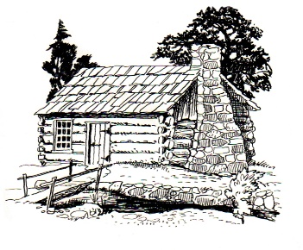
This Photo by Unknown Author is licensed under CC BY-SA
Notice of Meeting
Germantown Colony Museum
Advisory Board
Thursday, February 2, 2023
Meeting 4:30 p.m.
The Hocks Red Barn
1383 Hwy 531
Minden, LA
Meeting open to the public
Phone: 318-377-6061
P.O. Box 178 Minden, LA 71058

